Erciyes Üniversitesi
Fen Bilimleri Enstitüsü Dergisi
Cilt 34, Sayı 2 , 2018

Erciyes University
Journal of Institue Of Science and Technology
Volume 34, Issue 2, 2018

Morphological and Molecular Diversity Among Heliotropium greuteri Samples

Tuğçe Tecirli¹, Akife Dalda-Şekerci², Ömer Faruk Coşkun³, Osman Gülşen^{*4}

^{1,2,3,*4} Erciyes University, Faculty of Agriculture, Department of Horticulture, KAYSERİ, TURKEY

(Alınış / Received: 21.03.2018, Kabul / Accepted: 30.08.2018, Online Yayınlanma / Published Online: 31.08.2018)
Keywords  Heliotropium greuteri, Characterization,  ISSR,  Potential Ornamental Plant | Abstract: The aims of this study were to characterize Heliotropium greuteri H. RIEDL plants for some selected morphological characters, and to investigate their diversity and relationships by using inter-simple sequence repeat (ISSR) markers. Forty-seven H. greuteri and one H. lasiocarpum genotypes as control were used in this study. The plant materials were collected from the sites of Erciyes University and city of Develi, Kayseri, Turkey, and characterized for plant structure, flower structure, seed characteristics and molecular marker diversity. Plant heights ranged from 13 to 110 cm, averaging 28 cm. Flower diameters ranged from 1.35 to 18.5 mm, averaging 9.78 mm. All traits studied indicated variations, which were indicated potential for improvement as ornamental plant. For ISSR analysis, 13 ISSR primers selected based on initial screening with 20 primers were applied to all samples, which produced 90 polymorphic markers. Dice’s genetic similarity values varied between 0.81 and 0.99, which was relatively narrow. Probably this species faced a recent bottleneck or speciation has arisen recently resulting in narrowed diversity. Overall, H. greuteri plants indicated potential for ornamental use due to their relatively drought tolerance, fragrance, extended flowering time and honeybee attraction.
Heliotropium greuteri Örnekleri Arasındaki Morfolojik ve Moleküler Çeşitlilik
Anahtar Kelimeler  Heliotropium greuteri, Karakterizasyon,  ISSR,  Süs Bitkisi Potansiyeli | Öz: Bu çalışmada Heliotropium greuteri H. RIEDL bitkisinde seçilen bazı morfolojik karakterler bakımından karakterizasyonunu yapmak, ISSR markırları vasıtasıyla akrabalık ve çeşitliliklerini belirlemek amaçlanmıştır. Bu çalışmada kırk yedi H. greuteri genotipi ile kontrol olarak bir H. lasiocarpum genotipi kullanılmıştır. Bitki materyalleri Erciyes Üniversitesi ve Kayseri-Develi çevresinden toplanmıştır. Bitki yapısı, çiçek yapısı, tohum özellikleri ile moleküler markır çeşitlilikleri karakterize edilmiştir. Bitki yüksekliği 13-100 cm (ort:28 cm), çiçek çapı 1,35-18,5 mm (ort: 9,78 mm) olarak belirlenmiştir. Elde edilen veriler doğrultusunda; tüm özellikler bakımından varyasyon tespit edilmesi bu bitkinin süs bitkisi olarak geliştirilebilir bir potansiyele sahip olduğunu göstermektedir. ISSR analizlerinde, seçilen 13 primer ile 90 polimorfik bant elde edilmiştir. Dice genetik benzerlik değerleri 0,81-0,99 arasında bulunmuştur. Bu bağlamda bu tür bir darlaşma ile karşı karşıya kalmıştır ya da daralan çeşitlilikle sonuçlanan bir türleşme ortaya çıkmıştır. Genel olarak H. greuteri bitkileri kuraklık toleranslarının yüksek olması, kokuları, çiçeklenme sürelerinin uzunluğu ve bal arılarını cezbetme gibi özellikleriyle kurakçıl peyzajda süs bitkisi olarak kullanılmaları için önemli bir potansiyele sahiptir.

1. Introduction

More than 9000 seeded plants are naturally present in Turkey. More than 3.000 of these species are endemic to Turkey [1]. The Boraginaceae family is one of the most important among them. This family has 100 genera and 2.000 species in tropical, subtropical and temperate regions. They include herbs, shrubs and trees in the world. Within the Boraginaceae family, the Heliotropium genus show great differences in many of the biological features including habitat preferences, physiognomy and morphological characteristics. This genus contains almost 300 species [2]. The important diversity center of the genus is South-West and Central Asia. The plants of Heliotropium occur in areas with an arid and semi-arid climate, mostly on dry soils, sandy and gravelly deserts, disturbed soils as weeds in cultivated lands and wastelands along riversides [3, 4].

Among the people of Turkey, Heliotropium greuteri H. RIEDL is called ‘yoghurt otu’, bostan otu or ‘paslı bambul otu’. This species occurs in few locations of Turkey including Adana, Malatya and Bursa [5]. Based on our observations in the fields of Kayseri province, they benefit from loosened cultivated soils of seed pumpkin fields very common in this region with elevation ranging from 1.000 to 2.200 meter from the sea level in the slopes of Erciyes Mountain. Their plants form very showy larger sized plants in cultivated lands compared to those in non-cultivated areas.

Ornamental, genetic and biochemical properties of the H. greuteri plants has not been reported yet. There are several reports of the related species [6, 7]. In example, indicated that H. europaeum, a close relative of H. greuteri, was host for an important pathogen of tomato causing tomato leaf curl disease and tomato leaf curl Palampur virus [8]. The members of Heliotropium L. involved both C-3 and C-4 photosynthetic mechanism, which makes the genus important to elucidate evolution of these mechanisms [9]. In addition, the identification and characterization of ornamental plants with high resistance to drought is very important due to changing climate conditions. It is very important to characterization of alternative ornamental plants that have high resistance to drought and arid conditions. The aims of this study were to characterize Heliotropium greuteri H. RIEDL plants for some selected morphological characters and to investigate their diversity and relationships by using ISSR markers.

2. Material and Method

  - Plant materials

Forty-seven Heliotropium greuteri H. RIEDL and one H. lasiocarpum samples were obtained from the two sites of Kayseri, Develi and Kayseri in 2015. These two sites are divided by Erciyes Mountains. The evaluations were performed in-site or in the laboratory of Erciyes University (Table 1).

Table 1. The plants used in this study, the latitudes, longitudes and the regions where they are collected

Plant number | Latitude | Longitude | Region
1 | 38'41.859 | 35'32.249 | KAYSERİ
2 | 38'41.897 | 35'32.238 | KAYSERİ
3 | 38'41.938 | 35'32.207 | KAYSERİ
4 | 38'41.938 | 35'32.203 | KAYSERİ
5 | 38'41.935 | 35'32.191 | KAYSERİ
6 | 38'41.955 | 35'32.194 | KAYSERİ
7 | 38'41.933 | 35'32.102 | KAYSERİ
8 | 38'41.924 | 35'32.104 | KAYSERİ
9 | 38'41.892 | 35'32.094 | KAYSERİ
10 | 38'41.981 | 35'32.043 | KAYSERİ
11 | 38'41.959 | 35'32.191 | KAYSERİ
12 | 38'41.933 | 35'32.197 | KAYSERİ
13 | 38'41.932 | 35'32.196 | KAYSERİ
14 | 38'42.327 | 35'32.017 | KAYSERİ
15 | 38'42.327 | 35'32.020 | KAYSERİ
16 | 38'42.328 | 35'32.019 | KAYSERİ
17 | 38'42.301 | 35'32.051 | KAYSERİ
18 | 38'42.279 | 35'32.048 | KAYSERİ
19 | 38'42.276 | 35'32.051 | KAYSERİ
21 | 38'42.274 | 35'32.022 | KAYSERİ
22 | 38'42.215 | 35'32.152 | KAYSERİ
23 | 38'42.216 | 35'32.155 | KAYSERİ
24 | 38'42.228 | 35'32.169 | KAYSERİ
25 | 38'42.228 | 35'32.169 | KAYSERİ
26 | 38'42.226 | 35'32.171 | KAYSERİ
27 | 38'42.225 | 35'32.172 | KAYSERİ
28 | 38'42.227 | 35'32.172 | KAYSERİ
29 | 38'42.227 | 35'32.173 | KAYSERİ
30 | 38'42.227 | 35'32.174 | KAYSERİ
31 | 38'42.236 | 35'32.179 | KAYSERİ
32 | 38'42.233 | 35'32.181 | KAYSERİ
33 | 38'41.956 | 35'32.187 | KAYSERİ
34 | 38'41.957 | 35'32.191 | KAYSERİ
35 | 38'41.957 | 35'32.188 | KAYSERİ
36 | 38'41.956 | 35'32.190 | KAYSERİ
37 | 38'22.871 | 35'27.239 | DEVELİ
38 | 38'22.087 | 35'27.024 | DEVELİ
39 | 38'22.871 | 35'27.234 | DEVELİ
40 | 38'22.886 | 35'27.346 | DEVELİ
41 | 38'22.889 | 35'27.348 | DEVELİ
42 | 38'22.876 | 35'27.315 | DEVELİ
43 | 38'22.879 | 35'27.312 | DEVELİ
44 | 38'22.880 | 35'27.310 | DEVELİ
45 | 38'22.885 | 35'27.263 | DEVELİ
46 | 38'22.883 | 35'27.258 | DEVELİ
47 | 38'22.853 | 35'27.254 | DEVELİ
48 | 38'22.873 | 35'27.245 | DEVELİ
50 | 38’42.279 | 35’32.193 | KAYSERİ

  - Morphological characterization

The plants were evaluated for different phenotypic characteristics such as general appearance by using a likert scale of 1 (not good) to 5 (very good), branching by using a likert scale of 1 (not good) to 5 (very good), plant height (cm) leaf width (mm), leaf length (mm), leaf color measured by using a Konica Minolta Chroma Meter CR-400, flower top diameter (mm), flower bottom diameter (mm), spike length (cm), seed width (mm), seed length (mm), 1000-seed weight (gr).

  - Molecular marker analysis

Genomic DNA was isolated from young leaves of ﬁeld grown plants using modiﬁed CTAB method [10]. The quality and quantity of DNA isolated from these leaf samples were determined by agarose gel electrophoresis. The genomic DNAs were subjected to PCR ampliﬁcation using 13 ISSR primers selected from 20 primers. PCR reaction was performed in a 15 ul volume containing 1.5 ul Taq buffer A (10 mM Tris–HCl, pH 8.3 with 15 mM MgCl₂), 1.2 ul of 2.5 mM dNTPs, 0.2 ul of 3 unit of Taq DNA polymerase, 2 ul (20 ng) of template genomic DNA and 1 ul (5 pM) each of ISSR primers. Cycling conditions used for ISSR PCR ampliﬁcations were as follows: initial denaturation at 94°C for 5 min followed by 30 cycles of 94°C for 1 min, 55°C for 1 min, 72°C for 2 min and a ﬁnal extension step at 72°C for 5 min. The ampliﬁed products were resolved on 2% agarose gel at 70–80 V for 3.5–4 h, using TBE (Tris-Boric acid-EDTA) buffer, visualized under UV light after staining with ethidium bromide and photographed using gel documentation system (Kodak EL Logic 200). The size (bp) of the amplicons was determined by comparing their mobility with 100 bp DNA ladder as size standard.

  - Data analysis

Morphological data were created based on averages of 10 repetitions. Shapiro-Wilk test was used to test whether the samples had normal distribution, and Levene’s test was used to test variance homogeneity. One-way analysis of variance was performed to compare the samples by using SPSS 15.0 package program. For molecular data, only clear and reproducible DNA fragments were scored as 1–0 binary data matrix for the presence and absence of a band, respectively. The cluster analysis among the 48 plants of Heliotropium species for morphological and molecular data was performed based on correlation matrix for morphological data and the Dice’ similarity matrix for molecular data [11], and unweighted pair-group with arithmetic average method (UPGMA) algorithms nested in NTSYS-pc software (Numerical Taxonomy Multivariate Analysis System) version 2.1 [12].

- Results

  - Morphological characterization

The 48 plant samples including 47 H. greuteri and one H. lasiocarpum were characterized for their several morphological properties described above. The germination time was between late May and early June. The time of flowering was recorded as mid-June, and lasted until the first frost, usually mid-October. This has great value because this time of year usually lacks actively growing plants in Central Anatolia due to insufficient level of precipitation. It appeared that the flowering period of H. greuteri was significantly long, which was important for ornamental purpose and beekeeping. The plant height was measured as 13 cm minimum in plant number 19 in Kayseri and 110 cm maximum in plant number 39 in Develi (Table 2). General plant appearance and branching were scored using a scale 1 (not good) to 5 (very good), with averages of 3.34 and 3.58, respectively. Regarding branching, the least branching value (1) was observed in 4 of the plants while the highest scale (5) was present in 15 of the samples. Branching characteristics differed probably because of plants of different ages and environmental conditions. In some areas, despite removal of upper plant parts by gardeners, the plants was able to reproduce branches. This may indicate presence of cutting tolerance in these potential ornamental plants.

For general appearance of the plants, considerable diversity was observed among the samples, which also indicated potential for selection. 4 of 48 plants had very poor appearance (1), 7 had a rate of 2, 14 of medium, 13 indicated 4, and 10 had the best appearance (5).

Data of leaf size, leaf height, leaf width were presented in Table 2. The minimum value in the measurements made from the leaf blade was measured at the number 40 (5.2 mm), while the maximum value was found at the number 9 (28.9 mm) and the average was found to be 18.6 mm (Table 2). The highest number of leaves was observed in the plant number 9, while the numbers 2, 6, 7, 9, 16, 23, 30 and 32 were not statistically different. No statistically significant difference was observed among the samples 18, 21, 22, 33, 36, 37, 42 and 44 while the lowest value belong to plant number 40.

Leaf length was found to be 8.2 mm minimum in plant number 44 sampled from Develi, maximum 65.3 mm from plant number 9 from Kayseri and the average was 27.5 mm (Table 2). Plant number 9, having the highest value for leaf length, was not statistically different from 2, 14, 15, 17 and 32.

The minimum leaf width was found to be 3.35 mm in plant number 37 from Develi, the maximum value was 27.6 mm in plant number 30 from Kayseri, averaging 12.3 mm (Table 2). Flower upper diameter, flower lower diameter, spike length measurements were also studied. However, no statistically significant differences for these traits were observed among the plants. Heliotropium greuteri were also evaluated for seed properties. The largest seed size (2.24 mm) recorded in plant 43, and the smallest seed (1.68 mm) were measured in plant 3.

Correlation analysis among the phenotypic characteristics indicated few meaningful results. A positive correlation was observed between leaf length and leaf blade (r = 0.89). Similarly, there was a moderate correlation between the flower lower diameter and the flower upper diameter (r = 0.55). There was a positive moderate correlation between general appearance and branching (r = 0.65), but no correlation was found between the other morphological characters.

Table 2. The minimum, maximum, mean and standard deviations of the population for the morphological characters studied
 | Minimum | Maximum | Mean | Standard Deviation
Leaf blade (mm) | 5.16 | 38.65 | 18.62 | 5.46
Leaf width (mm) | 3.33 | 27.61 | 12.25 | 3.74
Leaf height (mm) | 8.17 | 65.28 | 27.45 | 8.41
internode (cm) | 0.50 | 9.10 | 2.74 | 1.21
Plant width (cm) | 13.00 | 110.00 | 28.59 | 15.8
Flower upper diameter (mm) | 1.35 | 18.54 | 9.78 | 1.73
flower lower diameter (mm) | 1.73 | 8.98 | 5.14 | 1.00
spike length (cm) | 0.80 | 10.60 | 4.39 | 1.74
Seed width ( mm) | 0.75 | 1.68 | 1.11 | 0.10
Seed length (mm) | 0.99 | 2.24 | 1.78 | 0.17
L* | 36.42 | 68.66 | 44.86 | 4.69
a* | -14.70 | -2.63 | -7.97 | 2.09
b* | -4.11 | -77.5 | -14.87 | 34.31

‘L’, ‘a’, ‘b’ values for leaf color were measured. ‘L’ has a maximum value of 100 and corresponds to the white color. In the measurements, ‘L’ value was found to be minimum of 36 and maximum of 69, averaging 45. We can interpret the measurements as medium brightness. Positive and negative ‘a’ represents red and green colors, respectively. No positive ‘a’ value was observed among the samples. ‘a’ values ranged from -14.70 to -2.63, with the average of -7.97. ‘b’ values were between -4.11 and -77.5 with the average of -14.87. The negative ‘a’ value corresponded dark green and bluish gray color due to the negative ‘b’ values.

3.2. UPGMA analyses of morphological and molecular data

The UPGMA analysis was performed for estimating genetic diversity and relationships among the samples based on morphological and molecular data. Morphological characters (general appearance, branching, plant height, internode, leaf width, leaf length, leaf color, flower upper diameter, flower lower diameter, spike length, seed width, seed length, 1000 seed weight) among the 48 samples were analyzed. The UPGMA dendrogram based on the correlation matrix indicating similarity values between each pair of the samples was generated for the forty-eight samples. This yielded two large groups at the similarity value of 0.43 to 1.00 (figure not shown). There were 20 and 28 individuals in group A and B, respectively.

For molecular analyses of the samples, 13 ISSR primers out of 20 primers produced 101 scorable bands, of which 90 was polymorphic. The most productive primer was (CA)₈R yielding 13 bands while the least productive was (AG)₈YC primer with 4 bands, averaging 7.76 bands per primer. The UPGMA dendrogram based on Dice’ similarity matrix resulted in two groups at the similarity level of 0.65 (Fig. 1). The most distinctive one was plant 48, H. lasiocarpum. The plants 40 and 48 were sampled from Develi city and very similar with the value of 0.91. Two H. greuteri samples, 8 and 31, were clustered separately from the rest of H. greuteri samples. These two samples were collected from the same area in Kayseri. The similar results were also observed between 2 and 3 and between 10 and 11, both pairs were sampled from the same location of Kayseri. The Mantel correlation coefficient (r) between Dice’ similarity and ultrametric distance (obtained from conversion of dendrogram to distance matrix) matrices was 0.82, meaning sufficient representation of the similarity matrix. Morphological and molecular data resulted in different grouping patterns. Probably, the first are affected/ modified by environmental factors such as water availability and nutrients [13].

- Discussion and Conclusion

İn this study, ornamental plant characteristics of forty-eight samples of the Heliotropium genus belonging to Boraginaceae family, 47 H. greuteri and one H. lasicarpum were investigated. All samples were distinguished from each other based on morphological and molecular data. Based on the observations made in this study, H. greuteri had good ornamental characteristics because of 1) extended flowering period up to four months, 2) showy plants harmonizing white and green plant parts, 3) fragrant flowers, and 4) considerable drought tolerance after young seedling stage (Fig. 2). They also attract honeybees, particularly during poor vegetation at the end of summer and in the first half of fall season. They can be used as cover plant. We think that it can be successfully used in open areas as well as under trees (in semi-shaded). Particularly, they can produce healthy plants in the borders where they are often exposed to drought stress. On the other hand, due to their non-hairy root structure, they may not be successful in avoiding soil erosion in sloppy areas. Enlargement of flower and leaf sizes may be potential research topics for H. greuteri. These characters can be improved by selecting promising genotypes among the collections or applying colchicine for polyplodization. Another research area would be improving germination time and rate, which was poor in our preliminary studies. The effects of seed treatment practices such as priming, hydration and vernalization on germination should be investigated.

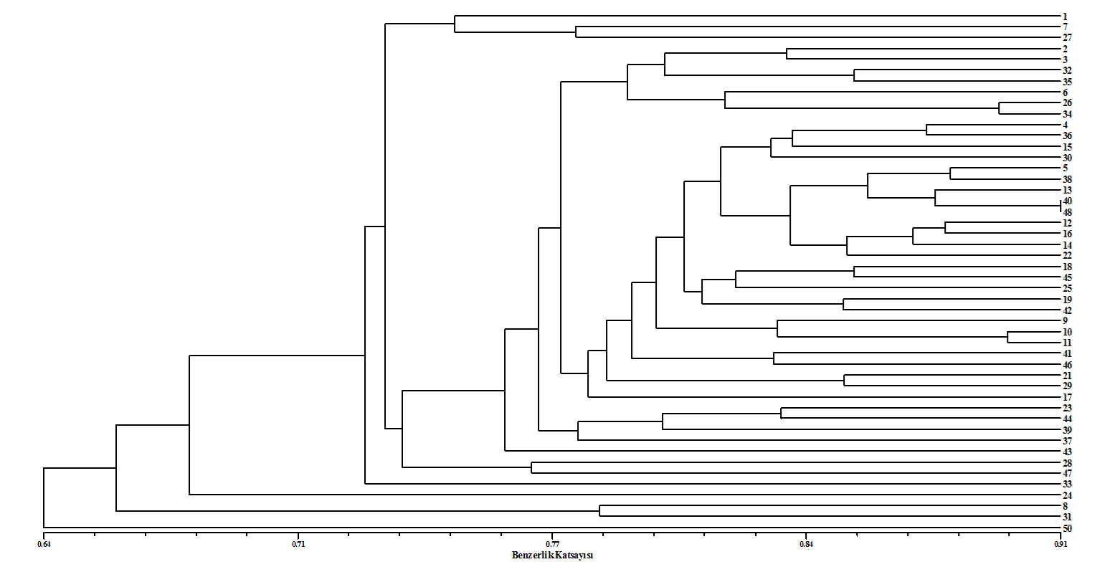
Similarity coefficient

Figure 1. The UPGMA dendrogram of 47 Heliotropium greuteri and one H. lasiocarpum plants based on the similarity matrix by using 13 ISSR markers

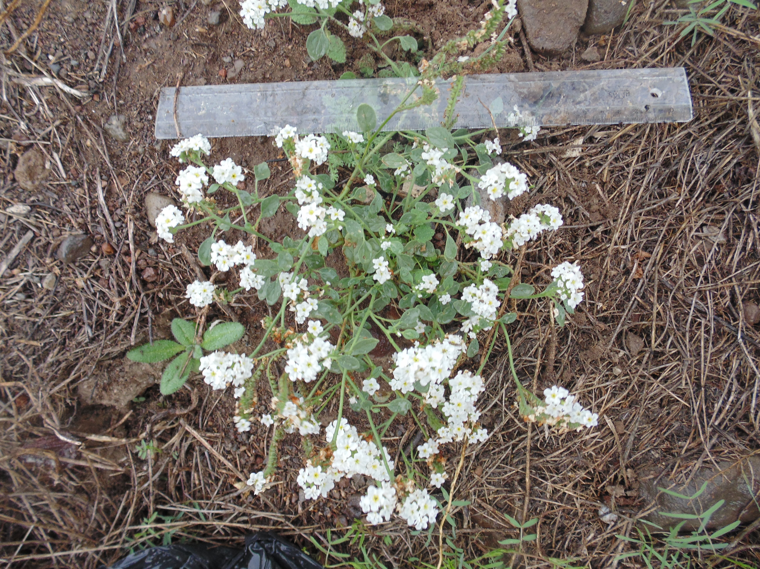

Figure 2. Naturally growing Helitropium greuteri plant in the Kayseri province of Turkey.

Acknowledgement

This study was financially supported by The Scientific Research Unit of Erciyes University under the project code FYL-2016-6432. The authors also thank Prof. Dr. Ahmet Aksoy for identification of Heliotropium greuteri and H. lasiocarpum.

References

- Kence, A. 1992. Biyolojik zenginlikler, sorunlar ve öneriler (in Turkish). Tarım ve Köyişleri Bakanlığı Dergisi, Sayı: 74. Ankara.

- Al-Turki, T.A., Omer, S., Ghafoor, A. 2001. Two new species of Heliotropium L. (Boraginaceae) from Saudi Arabia. Botanical J. Linnean Society, 137: 215-220.

- Collenette, S. 1999. Wild flowers of Saudi Arabia. Riyadh: National Commission for Wildlife Conservation and Development, p. 89-92.

- Akhani, H. 2007. Diversity, biogeography, and photosynthetic pathways of Argusia and Heliotropium (Boraginaceae) in South-West Asia with an analysis of phytogeographical units. Botanical J. Linnean Society, 155: 401-425.

- http://www.tubives.com/index.php?sayfa=1&tax_id=6420 (14.06.2016).

- Reddy, J.S., Rao, P.R., Reddy, M.S. 2002. Wound healing effects of Heliotropium indicum, Plumbago zeylanicum and Acalypha indica in rats. J Ethnopharmacology, 79: 249-251.

- Tosun, F., Tamer, U. 2004. Determination Of Pyrrolizidine Alkaloids In The Seeds Of Heliotropium europaeum. Bygc-MS. J. Fac. Pharm, 33: 7-9.

- Heydarnejad, J., Hesari, M., Massumi, H. 2013. Incidence and natural hosts of Tomato Leaf Curl Palampur Virus in Iran. Australasıan Plant Pathology, 42: 195-203.

- Muhaidat, R., Sage, T., Frohlich, M. 2011. Characterization of C-3-C-4 intermediate species in the genus Heliotropium L. (Boraginaceae): anatomy. Ultrastructure and enzyme activity. Plant Cell and Environment, 34:1723-1736.

- Doyle, J.J. 1990. Isolation of Plant DNA from fresh tissue. Focus, 12: 13-15.

- Dice, L.R. 1945. Measures of the Amount of Ecologic Association Between Species. Ecology, 26: 297-302.

- Rohlf, J.F. 2000. NTSYS-pc: numerical taxinomy and multivariate analysis system. Exeter software, Stauket, NY, USA.

- Gulsen, O., Sherman, R.C., Vogel, K.P., Lee, D.J., Paenziger, P.S., Heng-Moss, T.M., Budak, H. 2009. Nuclear genome diversity and relationships among naturally occurring buffalograss genotypes determined by sequence- related amplified polymorphism. Hortscience, 40: 537-541.

